Development of Cannabis Spectral Signatures
And
Cannabis Growth Simulation Model

Progress Report FY 2003

Charles L. Walthall

Craig S.T. Daughtry

Ludmila Pachepsky

November 3, 2003

USDA-ARS
Hydrology and Remote Sensing Laboratory
Rm. 104, Bldg. 007, BARC-W
Beltsville, MD 20707

Executive Summary

Under a Statement of Work developed with the National Guard Bureau Counter Drug Office (NGB-CD), the United States Department of Agriculture, Agriculture Research Service (USDA-ARS) has been tasked to characterize spectral reflectance signatures and research, evaluate and develop a cannabis growth simulation model to aid in illegal cultivation detection. This report documents activities conducted during FY 2003. Activities included 1) measurement of leaf optical properties of multiple varieties of cannabis, 2) analysis of cannabis leaf surface specular reflectance measurements, 3) acquisition of additional electron microscope photographs of cannabis leaf surfaces to further investigate factors contributing to cannabis spectral signatures, 4) analysis of airborne imagery investigating the potential of spectral and spatial signatures for detection, 5) acquisition of controlled climate growth chamber measurements and field measurements needed to parameterize the growth model, 6) continued growth model algorithm development, and 7) development of an L-systems graphical model as a user interface for the growth model. Parts of the growth model research were conducted on soybeans as a means of model validation, and seeking scientific community peer review without mention of cannabis. A manuscript describing the L-systems graphical output for the growth model using soybeans as the example has been accepted for publication in the Proceedings of the Fractals 2004 Conference to be held April, 2004. A paper was presented at the 2003 Office of National Drug Control Policy International Technology Symposium and published in the proceedings that details the factors causing cannabis spectral signatures to vary with sky conditions. Collaboration with NGB-CD program and the Maryland State Police Marijuana Eradication Program continued.
Table of Contents

I. Introduction and Problem Statement . . . . . . . . . . . . . . . . . . . . . . . . . . . . . . . . . . . 4

II. Marijuana Spectral Signatures Development . . . . . . . . . . . . . . . . . . . . . . . . . . . . 6

III. Marijuana Growth Simulation Model Development . . . . . . . . . . . . . . . . . . . . . .8

IV. Current Status . . . . . . . . . . . . . . . . . . . . . . . . . . . . . . . . . . . . . . . . . . . . . . . . .. .12

V. Other Activities . . . . . . . . . . . . . . . . . . . . . . . . . . . . . . . . . . . . . . . . . . . . . . . . . .13

VI. Appendices

Appendix A. VirCan: Virtual Cannabis Model Description
Appendix B. 2003 ONDCP International Technology Conference Paper
Appendix C. Fractals 2004 Conference Paper

I. Introduction and Problem Statements

Under a Statement of Work developed with the National Guard Bureau Counter Drug Office (NGB-CD), the United States Department of Agriculture, Agriculture Research Service (USDA-ARS) has been tasked to research, evaluate and develop a cannabis growth simulation model, and to characterize spectral reflectance signatures for cannabis. It is envisioned that the cannabis growth simulation model will help determine the most effective time of interdiction and eradication for illegal cultivation sites. The spectral signatures products will be used to investigate and develop remote sensing technologies such as hyper- and multi- spectral imaging to support Counter Drug Law Enforcement Agent (DLEA) illegal cultivation site detection missions. This project will further enhance the decision support capabilities of the evolving the Counter-Drug Geographical Regional Assessment Sensor System (CD-GRASS).

The Office of National Drug Control Policy sponsors the project with technical and administrative oversight by the NGB-CD. This document summarizes the activities for FY 2003.

Problem Statements

Illegal marijuana cultivation in the United States appears in all 50 states and is found on both public and private lands. Detection of illegal marijuana cultivation from airborne platforms is currently conducted using human observers. Successful detection of illegal marijuana cultivation depends on training, experience, and individual aptitude. The process is physically tiring for the aircrew, inefficient given the vast geographic areas routinely searched, and is often foiled by camouflaged grow sites. Detection also relies heavily on the synthesis of information from informants, historical information about cultivation, and growth site proximity to access roads, power lines, and water sources. Synthesis of these data and resulting stratification of the landscape for areas of increased probability of cultivation are now greatly assisted by the National Guard Bureau Counter Drug program Counter Drug Geographic Regional Assessment Sensor System (National Guard Bureau Counter Drug Office, 2000). An automated electro-optical (EO) remote sensing detection system would greatly enhance marijuana detection capabilities when used as a resource of the CD-GRASS.

It is desirable for eradication of growing plants by LEAs to be timed so that arrests of growers can be made. This requires an estimate of when growers will be on-site. Certain stages of growth may be more amenable to interdiction due to the need for specialized care of the plants during critical growing periods, or during harvest. Thus, if the timing of these stages can be estimated via a plant growth simulation model, a greater probability of arrest may result.

On-going research at the Beltsville Agricultural Research Center (BARC) on technologies for detection of illegal cannabis growth via remote sensing have been conducted since the early 1990s.

Task Order 1 (TO1) is Develop Marijuana Spectral Signatures. The objectives of TO1 for the first year of the project are:
1. Characterize marijuana leaf spectral signatures by growth stage
2. Assess spectral contrast between marijuana and other plants that may inhibit spectrally based detection

Task Order 1A (TO1A) is Development of a Marijuana Growth Model as an Aid for Detection of Marijuana Cultivation. The objectives of TO1A for the first year of the project are:
1. Feasibility study for development of the model
2. Assess how the growth model can be integrated into CD-GRASS
3. Start model development

BARC is a DEA-licensed location for marijuana growth research. Secure indoor and outdoor facilities exist on-site that are used for the research. This includes greenhouses, growth chambers and an outdoor “Garden”. The field is large enough to be useful for airborne remote sensing research. This facility has proven useful as an outdoor classroom for training LEA marijuana aerial spotters.

Principle investigators for the research are Drs. Charles L. Walthall, Physical Scientist and Craig S.T. Daughtry, Research Agronomist. The growth model algorithm is being development by Dr. Ludmila Pachepsky. Collaborations with Dr. John Lydon, Research Agronomist are contributing significantly to the research. Malachi Pringle, a biological technician oversaw growth chamber operations. Monisha Kaul assists with growth chamber and outdoor plant measurements.
II. Spectral Signatures Development

Aerial spotters report that the blue-green or “emerald green” appearance of Cannabis is one of the characteristics used to detect illegal Cannabis cultivation. This characteristic appears to be unique to Cannabis and may provide a signature that can be exploited for detection. Analysis of laboratory specular reflectance measurements and a new series of micrographs of Cannabis leaf surfaces were done to better understand the mechanisms contributing to the “emerald-green” reflectance. Dr. Vern Vanderbilt of NASA Ames Research Center, Moffet Field, California is cooperating on this analysis. The source of the specular component appears to be 1) the waxy cuticle layer of the leaves and 2) scattering from microscopic structures on the surface of the leaves. The specular component preferentially scatters blue sky-light and adds this to the green reflectance of the chlorophyll-bearing leaf structures thus resulting in a blue-green or “emerald green” reflectance. The plant canopy signature of Cannabis is variable because of the blue specular component: under clear skies the blue specular reflectance will be stronger, whereas under hazy or cloudy skies the blue specular reflectance will be weaker and will result in a spectral signature dominated by the green reflectance of the internal leaf elements.

A database of leaf specular reflectance was collected by Dr. Vanderbilt during the early 1990s. This is being accessed for comparison to the leaf specular reflectance of Cannabis leaves. The entire database will have to be reprocessed before comparison with the Cannabis data. Calibration is still being addressed.

Hemispherical leaf reflectances of different Cannabis varieties were measured (Figure 1). The leaf widths of several varieties were too narrow for the integrating sphere port, thus reducing the number of samples. Contrast analysis showed that there do not appear to be significant spectral differences between the leaves of different varieties. This also suggests that the amount of THC present does not affect leaf reflectance, as expected.

Analysis of the calibrated airborne imagery collected over BARC and adjacent land cover types of Beltsville was continued to assess which spectral bands are most critical for spectral discrimination (Figure 2). It appears that the 16 spectral bands of the over flight covering the visible through near infrared are inadequate for separating the Cannabis plant canopy cover spectral reflectance from the reflectance of other types of plant canopies.

Additional analysis of the airborne imagery was conducted addressing both spatial and spectral aspects of Cannabis cultivation. Image spatial parameters were calculated from the apparent reflectance imagery by Dr. Melinda Higgins, Georgia Technical Research Institute and provided to us. The spatial parameters are being explored as additional signatures vectors for detecting illegal cultivation. The parameters were treated as ancillary data and together with the reflectance data, subjected to traditional image classification routines. If the spectral-spatial signature of the Cannabis cultivation site was unique, then it would be possible to isolate its signature. The results showed that the spatial parameters did not provide additional information that could be used to isolate a Cannabis cultivation signature.

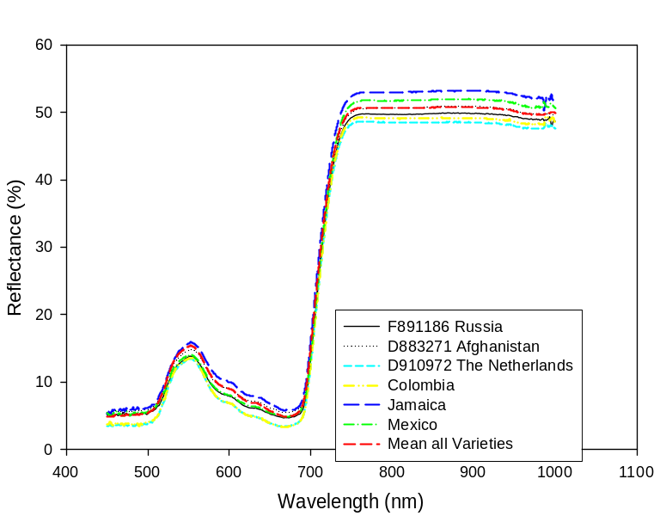

Figure 1. Hemispherical leaf reflectance of different Cannabis varieties.
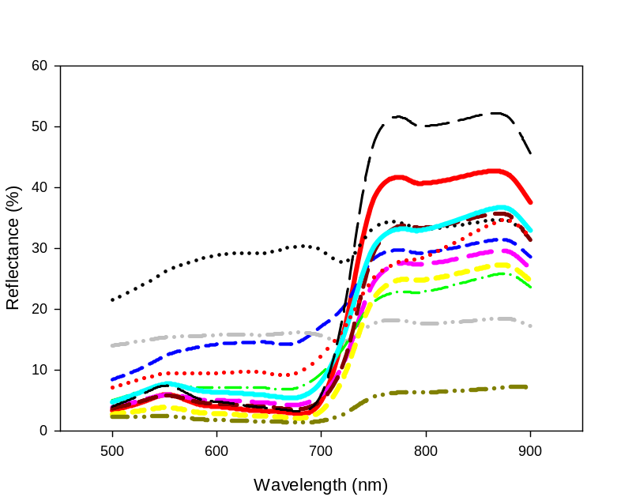
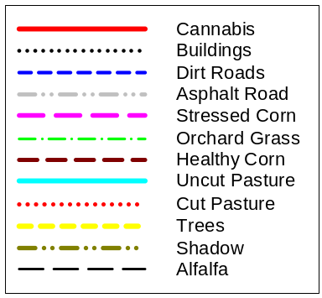

Figure 2. Spectral signatures from the image classification analysis. Although the Cannabis signature looks separable in the red to near infrared rise and the near infrared shoulder, the classification resulted in many conflicts with different land covers.

II. Growth Model Development

A mix of low and high THC content plants were propagated from seeds acquired under DEA license from The Netherlands. Young plants were transplanted from the secure greenhouse facility to the secure outdoor growth facility at the start of the growing season. A micrometeorological weather station was situated next to the field.

The secure growth chambers were maintained to operational status. Two series of experiments in the growth chambers with two different varieties of Cannabis at three air temperatures (a signficant environmental characteristic influencing growth) were completed. The primary data analysis was conducted and the results were prepared for use with a “conventional”model and a “visual model”.

Plant growth measurements were made of Cannabis plants in the outdoor growth facility. These measurements were used as validation points for the Cannabis growth model. The validation process includes comparisons of model output run using the growth chamber data for model parameterization, and for adjustments of growth model parameters.

Meta data of all measurements on plants grown in the growth chambers and in the field was compiled and organized for incorporation into analysis supporting the growth model development.

A “conventional” simulation model, CanMod, that captures the growth and development processes of Cannabis responses to management, genotypic, and climate factors has been developed. Preliminary parameterization and validation with published experimental data (available in a very limited amount for marijuana and hemp) has been made.

For visual modeling, the CPFG Virtual Laboratory has been chosen as the software platform. This is a plant simulation program based on the formalism of Lindenmayer systems (L-Systems). A distinctive feature is its flexible modeling language that allows specification of the architecture of plants. For the purposes of remote sensing and detection, this software has a useful option of specifying materials with specific optical properties and, thus simulates the reflectance characteristics of leaves, plants, and canopies. This system allows us to investigate the impact of physiological (e.g., cultivar) and environmental processes on plant development using a functional-structural model of a plant. The results are visualized as realistic images of plants. Numerical results are output in user-defined formats as needed for further analysis. The commercially-available L-Studio software allows us to simulate environmental processes such as “collision detection” between organs and plants, light distribution in the canopy, and transport of substances in plants and soils. Potential applications include simulation studies of plant architecture, development of detailed models of specific plants under specific conditions, additional visual validation of plant models, and creating a visual user-friendly interface.

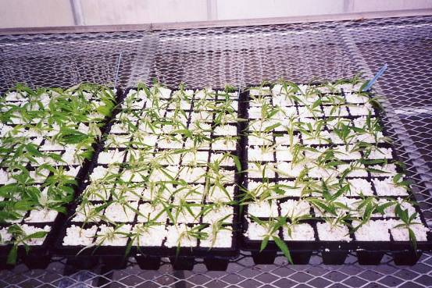

Figure 3. Young Cannabis plants in the secure greenhouse being grown for study. Multiple varieties are represented. Most are cloned from larger plants grown from seeds.

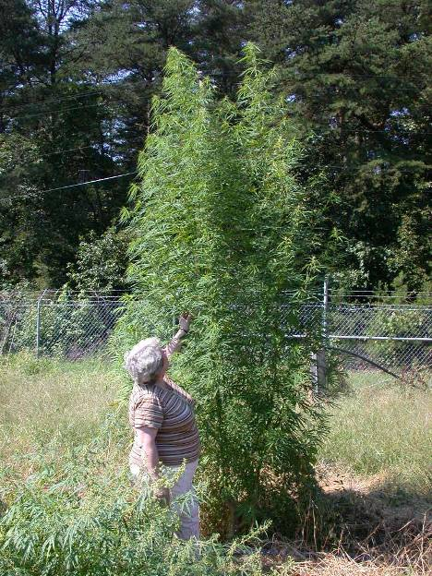

Figure 4. Photo of one Cannabis plant grown in the secure outdoor growth facility during 2003. The height was estimated to be 2.5 m.

The L-Systems software was purchased after testing a demonstration version. During the process of learning the techniques of visual modeling with L-Studio, several realistic dynamic, visual models of plants were developed. These models were developed using different options in the L-systems modeling language to determine an optimal approach to visual modeling for the Cannabis visual plant model. The models can be run in the L-Studio environment as well as recorded as movies and demonstrated on a variety of media players, and during Power Point presentations. These models can be manipulated (currently only manually) in terms of the growth and development parameters, and the distribution of sizes of particular organs (leaves are the most important).

Testing of the current model continued using data collected from the literature and the growth chamber experiments. The current model version provides satisfactory agreement with the experimental data of Cannabis development, and the phenological module of the model performs adequately. However, a more sophisticated model that includes a detailed description of carbon assimilation and partitioning is needed to simulate characteristics important for detection. Foliage density expressed as Leaf Area Index (LAI) and the optical qualities of the leaves are the most important elements needed.

Growth measurements of soybeans were also made in smaller, more reliable growth chambers to test several of the more recently developed growth model sub-modules. Soybeans were chosen because of their similarity to Cannabis in terms of growth and adaptability to different environmental conditions. This also permitted us the opportunity to conduct relevant measurements using more reliable growth chambers without the need for addition of the security system and applying for an additional DEA license. Measurements on soybeans also allows us to publish reports of the model in the general scientific literature without reference to the use of Cannabis as the primary study species.

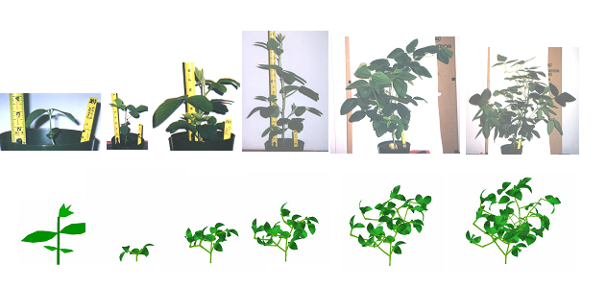
Figure 5 . Comparison of growth chamber-grown soybean plants with an L-Systems virtual model showing development. Soybeans were used while learning L-Systems in lieu of Cannabis to avoid the additional resources needed for secure growth chambers, the relatively rapid growth response of the plants, and to provide an alternative plant for reporting methods to the scientific community.

IV. Current Status

Hurricane Isabel damaged plants in the outdoor growth facility during late September, thus terminating spectral measurements and growth model measurements for the year. Propagation of new plants in the secure greenhouse was begun.

Analysis of leaf specular reflectance data with an emphasis on calibration continues. Reprocessing of the leaf specular reflectance data collected by Dr. Vanderbilt is also underway.

Processing of the leaf hemispherical data collected for assessment of the spectral effects of THC is underway. We are currently assessing contacts and resources for the THC content measurements.

A manuscript suitable for submittal to a refereed scientific journal is being written. This paper expands on the spectral signature issues presented at the 2003 ONDCP International Technology Symposium. Authors are Walthall (USDA), Daughtry (USDA), Vanderbilt (NASA), Lydon (USDA), Bobbe (USDA Forest Service), Higgins (GTRI/CD-GRASS), Erbe (USDA).

Drs. Walthall and Daughtry are collaborating with Dr. Melinda Higgins (GTRI/CD-GRASS) on the design of an experiment to assess the utility of more sophisticated hyperspectral imaging systems that cover short wave infrared (1100 – 2200+nm) wavelengths. This activity also involves the Naval Research Laboratory, and the Mississippi Center for Higher Learning.

V. Other Activities

Drs. Walthall and Daughtry hosted Dr. Melinda Higgins for a one-day visit during March, 2003. Dr. Higgins is the senior research scientist at GTRI for the CD-GRASS project. She was briefed on the status of the signature analysis, growth model analysis, and growth model 3-D graphics. Discussions on a joint effort to explore image spatial information as an additional aid for detection were held and plans made to conduct this analysis using a data set collected over BARC.

Dr. Daughtry attended the DEA Marijuana Eradication Conference April 14 and 15, 2003 in San Antonio, TX and made a presentation with Nick Faust of GTRI on remote sensing and GIS research of the CD-GRASS project.

Dr. Walthall attended the 2003 Annual American Society for Photogrammetry and Remote Sensing Conference, Anchorage, Alaska May 5-9, 2003. During a poster session he met Beth H. Skubis of the DCI Crime and Narcotics Center, Washington DC. Dr. Skubis is investigating hyperspectral remote sensing to support CIA narcotic crop surveys. Dr. Skubis has requested copies of USDA Cannabis and Coca leaf optical property data which will be provided on CD. She is also planning to visit BARC research facilities and to meet with Drs. Walthall and Daughtry on the use of remote sensing to detect and quantify illegal narcotic crop cultivation.

Dr. Walthall gave an invited presentation entitled “What do we know about the spectral signatures of illegal Cannabis cultivation?” at the 2003 ONDCP International Technology Symposium, July 9-11, San Diego, California. A paper was published in the conference proceedings. Authors included Daughtry (USDA), Vanderbilt (NASA), Higgins (GTRI/CD-GRASS), Bobbe (USDA Forest Service), Lydon (USDA), Kaul (USDA).

Drs. Daughtry and Walthall co-hosed Aerial Spotter Training by Sgt. Harry McDaniel of the Maryland State Police. Short presentations on various technology research programs focused on developing new counter-drug technologies were given by Dr. Walthall.

A poster presentation by Ludmila Pachepsky on the use of L-Systems for graphical output of plant growth models was accepted for the American Society of Agronomy annual meetings, Denver, Colorado for October, 2003. Soybean plants were used for the laptop computer demonstration software that accompanies the poster presentation.

Another presentation by Ludmila Pachepsky on the details of the L-Systems plant growth model output was accepted by the Fractals 2004 Conference, Vancouver, Canada.

